Debugging with Pipes

In this lecture, we are going to talk about one more pipe for helping us debug our applications. It’s called the **JsonPipe**.

<https://v17.angular.io/api/common/JsonPipe>

<https://angular.dev/api/common/JsonPipe>

According to the description, it was added to help with debugging. It’s not meant for production apps. The **JsonPipe** will output an object or array onto the page.

Let’s create an object to output in our template.

Open the app component class file:

Create a property called **pizza**, it will have two properties called **toppings and size.**

The **toppings property** will be an array of **pizza toppings.** As for the  **size property** we will set it to **large**:

**pizza = { toppings: [‘pepperoni’, ‘bacon’], size: ‘large’ };**

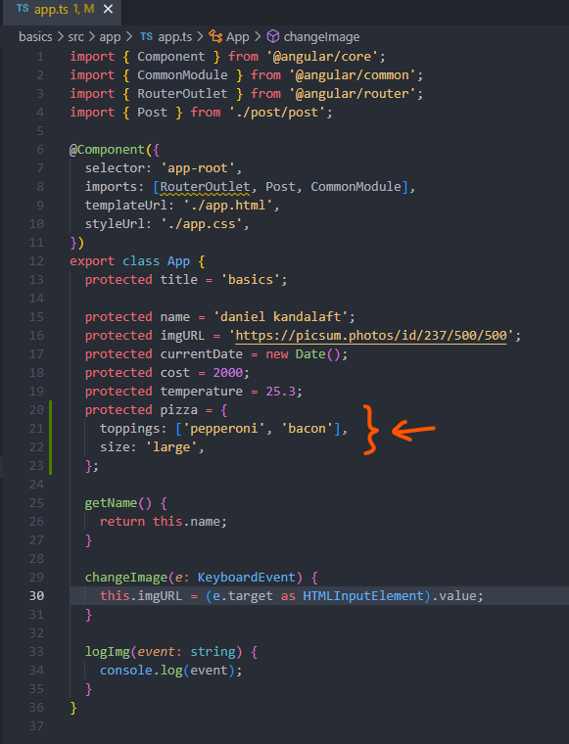

Next, let’s output this property.

Open the app template file:

Underneath the paragraph tags, we will add some <pre> tags. Inside these tags, we will add an expression for the pizza property with **JsonPipe**.

**<pre>{{ pizza | json }}</pre>**

**Without this pipe, the browser would not output the object.**

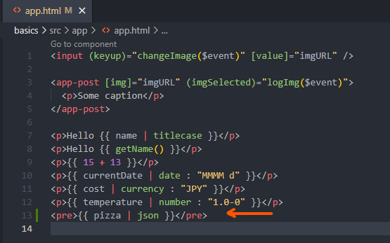

Let’s check out the page in the browser:

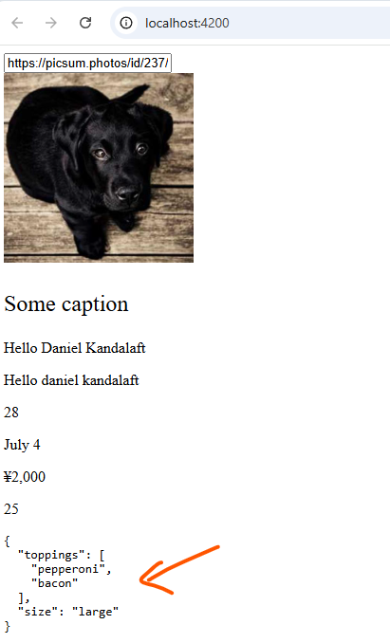

**By using the Json pipe, we have another way of viewing the contents of an object outside the developer tools. It’s great for debugging, but it’s not useful other than for development. We will be using this pipe to help us debug our app from time to time.**